**Conduct Pearson’s regression to determine the agreement between all parameters with the outputs (Cu and Cc) and present basic linear fittings.**

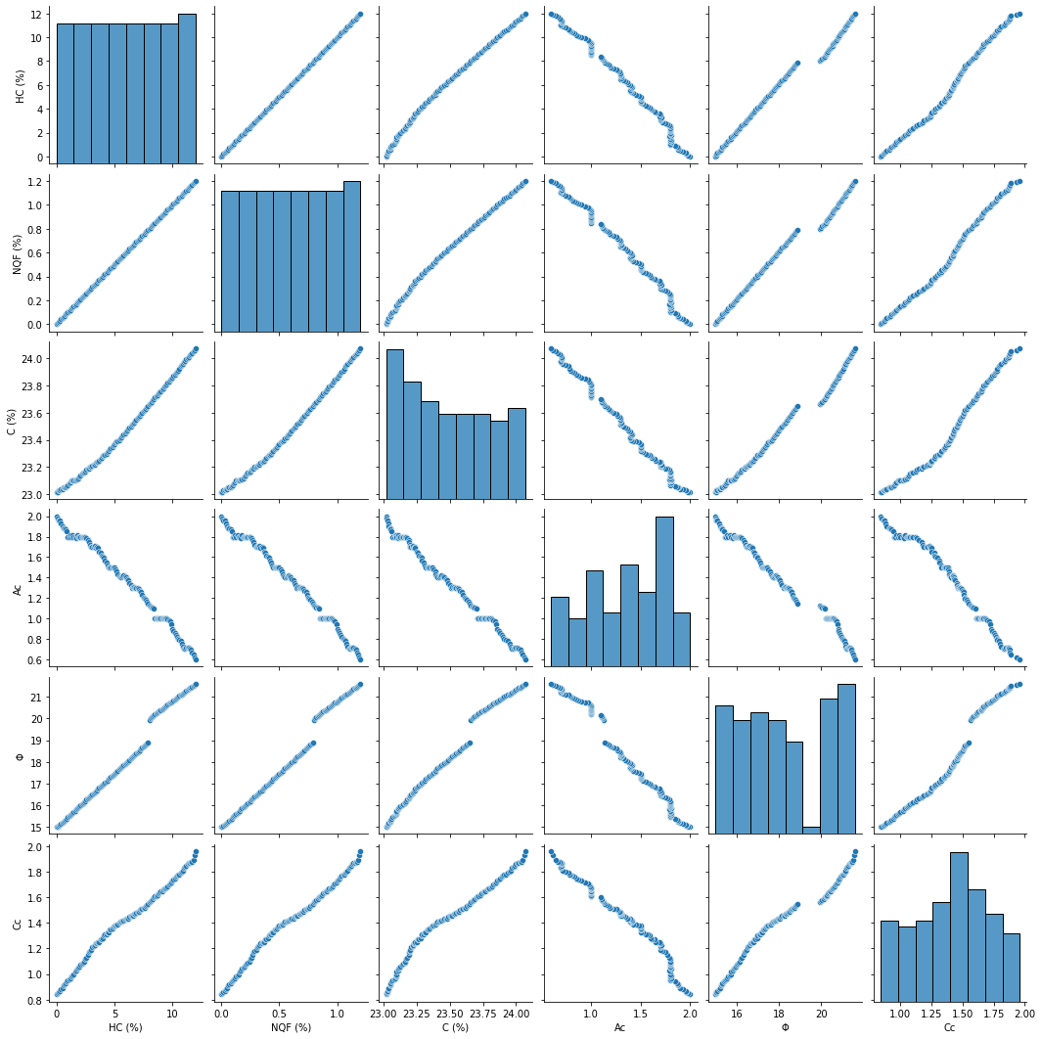

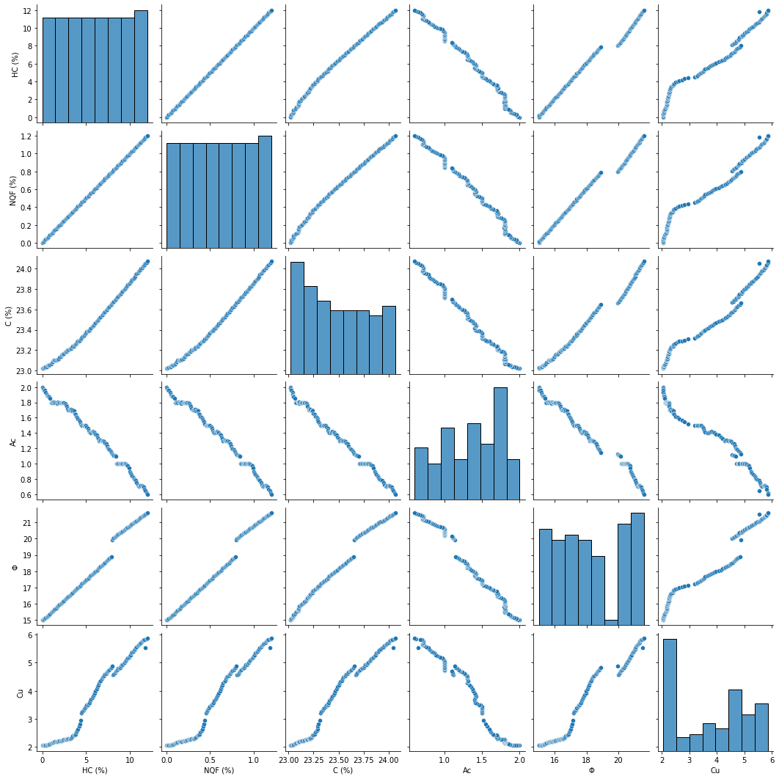

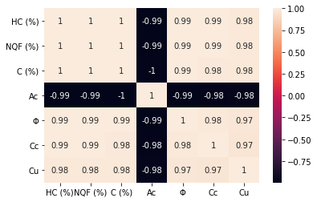

**Present frequency histograms of the variables.**

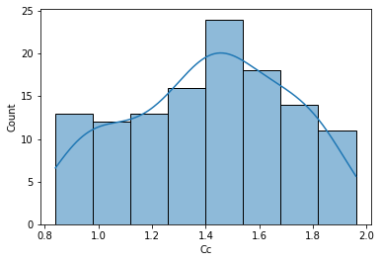

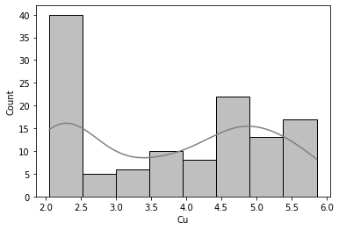

**Train, Validate and Test. Present the architecture of the program.**

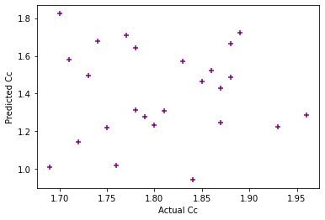

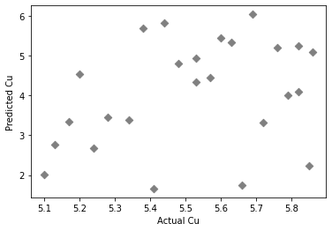

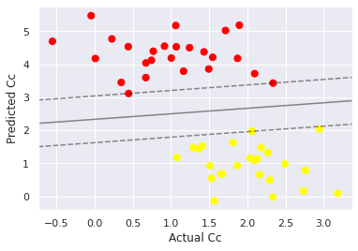

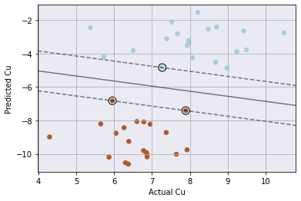

**Conduct performance evaluation in comparison between measured and predicted values using MLR, R^2, RMSE, MAE, MSE, and any other evaluation parameter.**

|  |  |  |
| --- | --- | --- |
|  | **Cc** | **Cu** |
| **Mean absolute error** | 0.034682960358232554 | 0.15082569068814503 |
| **Mean squared error** | 0.0018993085134429103 | 0.046887312023559294 |
| **Root mean squared error** | 0.04358105681879353 | 0.21653478247976535 |
| **R2 Score** | 0.9707178116877107 | 0.9710539671268553 |

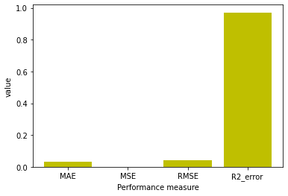

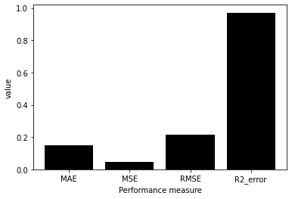

**Present the parametric study graph**

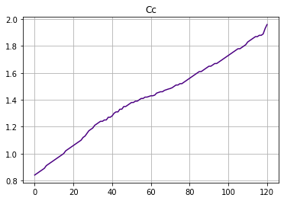

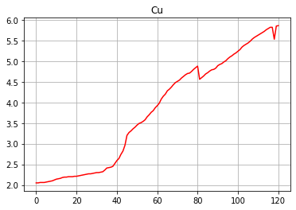

**Conduct sensitivity analysis to determine the influence of each parameter on the predicted parameters.**

